**Street Light Controller**



Session: 2021 – 2024

**Submitted by:**

Zainab Idrees , 2022-CS-199

**Supervised by:**

Mr. Muhammad Waseem

Department of Computer Engineering

**University of Engineering and Technology**

**Lahore, Pakistan**

# Street Light Controller Using Timer(Flip-Flop)

The proposed project aims to build a fully functional street light controller using a 555 IC. A 555 IC is a timer circuit that employs an SR-Flip Flop in its working. SR flip-flop, also known as a SR Latch, can be considered as**one of the most basic sequential logic circuit possible.**This simple flip-flop is basically a one-bit memory bistable device that has two inputs, one which will “SET” the device (meaning the output = “1”), and is labelled S and one which will “RESET” the device (meaning the output = “0”). Besides this, there are two 4.7 kΩ resistors, one 1kΩ resistor, one 0.1 microFarad capacitor and one 100 microFarad capacitor. The circuit is shown below:

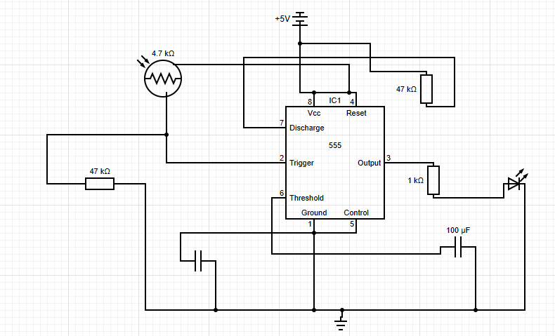

The circuit inside a timer utilizing a SR FlipFlop is shown below:

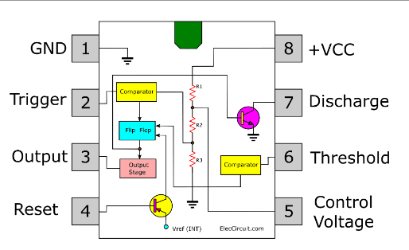

The Flip-Flop (between 2 and 3) is as follows:

